HA cluster configuration guide for SAP HANA on RHEL
This guide shows you how to deploy and configure a Red Hat Enterprise Linux (RHEL) high-availability (HA) cluster for an SAP HANA 2.0 SPS 05 or later scale-up system on Viatris VMware Infra.
This WI includes the steps for:
- Configuring a Pacemaker cluster on RHEL to manage the SAP systems and other resources during a failover
This WI also includes steps for configuring SAP HANA system replication but consult to the SAP Basis Team and SAP documentation for the definitive instructions.
The system that this guide deploys
Following this guide, you will deploy two SAP HANA Virtual Machines and set up an HA cluster on RHEL. You deploy each SAP HANA Virtual Machines on a different ESXi Host within the same Datacenter/ Cluster (preferred to build in).
The deployed cluster includes the following functions and features:
- Two host VMs, each with an instance of SAP HANA
- Synchronous SAP HANA system replication.
- The Pacemaker high-availability cluster resource manager.
- A STONITH fencing mechanism.
- Automatic restart of the failed instance as the new secondary instance.
Prerequisites
- Before you create the SAP HANA high availability cluster, make sure that the following prerequisites are met:
VMware Configuration:
- Both servers are in individual ESXi host to achieve Host level redundancy.
  - Add affinity rule to keep the VMs running in different host at the VMware cluster. (refer MYL-UNX-SOP-VMARP- 001)
- Disable DRS automation level to Manual (Refer SOP)
- Both VMs should be use individual data store
- Both VMs should have Same amount of CPU and Memory allocation.
- Both VMs should added in the VM folder “Unix RP1-osfence”. So that service account should have access to the VM.
Note: Service account having below privilege:
  - System.Anonymous
  - System.View
  - VirtualMachine.Interact.PowerOff
  - VirtualMachine.Interact.PowerOn
- Both servers should deploy from Mylan Approved template and required pre-requisites should meet based on the application requirement.
- Both the node configured with required mount points
- Disable IPv6 addressing in both server
High Level Diagram:
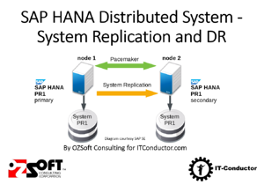
Checking the configuration of the VMs and SAP HANA
- After the SAP HANA system deploys without errors, connect to each VM by using SSH.
- Change to the root user.
$ sudo su –
- At the command prompt, enter df -h. On each VM, ensure that you see the /hana directories, such as /hana/data.
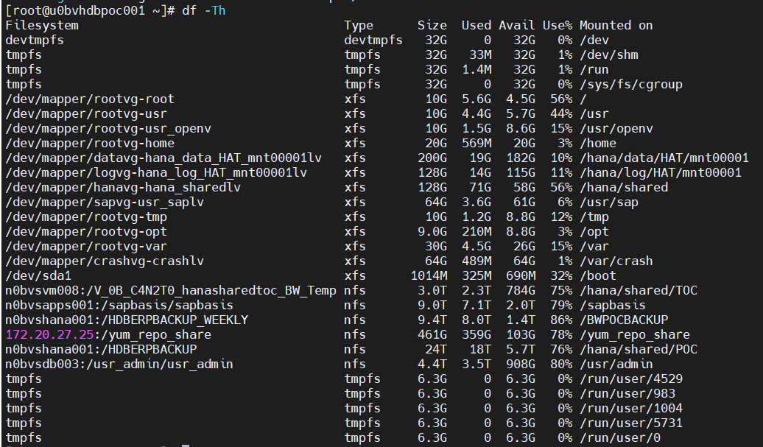
- Change to the SAP admin user
# su - hatadm
- Ensure that the SAP HANA services, such as hdbnameserver, hdbindexserver, and others, are running on the instance by entering the following command:
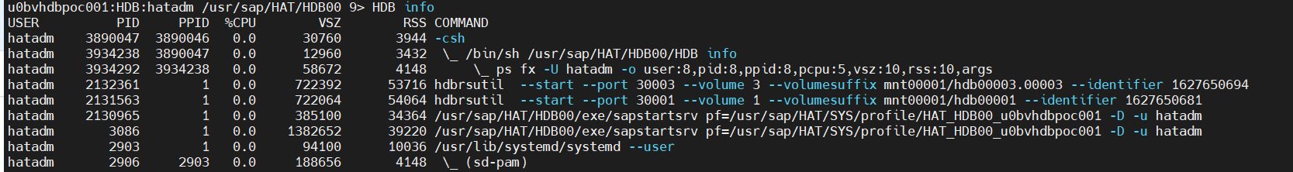
Disable SAP HANA autostart
For each SAP HANA instance in the cluster, make sure that SAP HANA autostart is disabled. For failovers, Pacemaker manages the starting and stopping of the SAP HANA instances in a cluster.
- On each host as hatadm, stop SAP HANA:
> HDB stop
- On each host, open the SAP HANA profile by using an editor, such as vi:
vi /usr/sap/HAT/SYS/profile/HAT_HDB00_u0bvhdbpoc001
- Set the Autostart property to 0:
Autostart=0
- Save the profile.
- On each host as hatadm, start SAP HANA:
> HDB start
Back up the databases
Create backups of your databases to initiate database logging for SAP HANA system replication and create a recovery point.
If you have multiple tenant databases in an MDC configuration, back up each tenant database.
The Deployment Manager template uses /hanabackup/data/SID as the default backup directory.
To create backups of new SAP HANA databases:
- On the primary host, switch to hatadm. Depending on your OS image, the command might be different.
sudo -i -u hatadm
- Create database backups:
- For a SAP HANA single-database-container system:
> hdbsql -t -u system -p <system-password> -i <inst-num> "backup data using file ('full')"
The following example shows a successful response from a new SAP HANA system:
0 rows affected (overall time 18.416058 sec; server time 18.414209 sec)
- For a SAP HANA multi-database-container system (MDC), create a backup of the system database as well as any tenant databases:
> hdbsql -t -d SYSTEMDB -u system -p <system-password> -i <inst_num> "backup data using file ('full')"
> hdbsql -t -d SID -u system -p <system-password> -i <inst-num> "backup data using file ('full')"
The following example shows a successful response from a new SAP HANA system:
0 rows affected (overall time 16.590498 sec; server time 16.588806 sec)
- Confirm that the logging mode is set to normal:
> hdbsql -u system -p <system-password> -i <inst_num> "select value from "SYS"."M_INIFILE_CONTENTS" where key='log_mode'"
You should see:
VALUE
"normal"
Enable SAP HANA system replication
As a part of enabling SAP HANA system replication, you need to copy the data and key files for the SAP HANA secure stores on the file system (SSFS) from the primary host to the secondary host. The method that this procedure uses to copy the files is just one possible method that you can use.
- On the primary host as hatadm, enable system replication:
u0bvhdbpoc001> hdbnsutil -sr_enable --name= u0bvhdbpoc001
- On the secondary host as hatadm, stop SAP HANA:
u0bvhdbpoc002> HDB stop
- On the primary host, using the same user account that you used to set up SSH between the host VMs, copy the key files to the secondary host. For convenience, the following commands also define an environment variable for your user account ID:
$ sudo cp /usr/sap/HAT/SYS/global/security/rsecssfs ~/rsecssfs -r
$ sudo chown hatadm -R /home/hatadm/rsecssfs
$ scp -r rsecssfs hatadm@ u0bvhdbpoc002:rsecssfs
$ rm -r /home/hatadm/rsecssfs
- On secondary host, as the same user as the preceding step:
- Replace the existing key files in the rsecssfs directories with the files from the primary host and set the file permissions to limit access:
$ sudo rm /usr/sap/HAT/SYS/global/security/rsecssfs/data/SSFS_HAT.DAT
$ sudo rm /usr/sap/HAT/SYS/global/security/rsecssfs/key/SSFS_HAT.KEY
$ sudo cp /home/hatadm/rsecssfs/data/SSFS_HAT.DAT \
/usr/sap/HAT/SYS/global/security/rsecssfs/data/SSFS_HAT.DAT
$ sudo cp /home/hatadm/rsecssfs/key/SSFS_HAT.KEY \
/usr/sap/HAT/SYS/global/security/rsecssfs/key/SSFS_HAT.KEY
$ sudo chown hatadm:sapsys /usr/sap/HAT/SYS/global/security/rsecssfs/data/SSFS_HAT.DAT
$ sudo chown hatadm:sapsys \
/usr/sap/HAT/SYS/global/security/rsecssfs/key/SSFS_HAT.KEY
$ sudo chmod 644 \
/usr/sap/HAT/SYS/global/security/rsecssfs/data/SSFS_HAT.DAT
$ sudo chmod 640 \
/usr/sap/HAT/SYS/global/security/rsecssfs/key/SSFS_HAT.KEY
- Cleanup the files in your home directory.
$ rm -r /home/hatadm/rsecssfs
- As hatadm, register the secondary SAP HANA system with SAP HANA system replication:
> hdbnsutil -sr_register --remoteHost=u0bvhdbpoc001 --remoteInstance=<inst_num> \
--replicationMode=syncmem --operationMode=logreplay --name=u0bvhdbpoc002
- As hatadm, start SAP HANA:
> HDB start
Validating system replication
On the primary host as hatadm, confirm that SAP HANA system replication is active by running the following python script:
$ python /usr/sap/HAT/HDB00/exe/python_support/systemReplicationStatus.py
If replication is set up properly, among other indicators, the following values are displayed for the xsengine, nameserver, and indexserver services:
- The Secondary Active Status is YES
- The Replication Status is ACTIVE
Also, the overall system replication status shows ACTIVE.
Install the cluster agents on both nodes
Complete the following steps on both nodes.
- As root user, Register the server with Redhat and attached Red Hat Enterprise Linux for SAP Solutions License to the server by,
[root@u0bvhdbpoc002 ~]# subscription-manager register
Registering to: subscription.rhsm.redhat.com:443/subscription
Username: mylaninfraunix
Password:
The system has been registered with ID: 23ffdcce-f807-471c-9541-ebed2aac90e5
The registered system name is: u0bvhdbpoc002
[root@u0bvhdbpoc002 ~]# subscription-manager attach --pool=8a85f99b790faed7017913ffc25e3548
Successfully attached a subscription for: 60 Day Evaluation of Red Hat Enterprise Linux for SAP Solutions, Self-support (Physical or Virtual Nodes)
[root@u0bvhdbpoc002 ~]#
- Enable “rhel-8-for-x86_64-highavailability-rpms, rhel-8-for-x86_64-sap-solutions-rpms, rhel-8-for-x86_64-appstream-rpms, rhel-8-for-x86_64-baseos-rpms” repos to get required packages to be installed.
[root@u0bvhdbpoc002 ~]# subscription-manager repos --enable=rhel-8-for-x86_64-highavailability-rpms
Repository 'rhel-8-for-x86_64-highavailability-rpms' is enabled for this system.
[root@u0bvhdbpoc002 ~]# subscription-manager repos --enable=rhel-8-for-x86_64-sap-solutions-rpms
Repository 'rhel-8-for-x86_64-sap-solutions-rpms' is enabled for this system.
[root@u0bvhdbpoc002 ~]# subscription-manager repos --enable=rhel-8-for-x86_64-appstream-rpms
Repository 'rhel-8-for-x86_64-appstream-rpms' is enabled for this system.
[root@u0bvhdbpoc002 ~]# subscription-manager repos --enable=rhel-8-for-x86_64-baseos-rpms
Repository 'rhel-8-for-x86_64-baseos-rpms' is enabled for this system.
[root@u0bvhdbpoc002 ~]# yum repolist
Updating Subscription Management repositories.
Red Hat Enterprise Linux 8 for x86_64 - SAP Solutions (RPMs) 26 kB/s | 15 kB 00:00
Red Hat Enterprise Linux 8 for x86_64 - High Availability (RPMs) 2.9 MB/s | 1.8 MB 00:00
Red Hat Enterprise Linux 8 for x86_64 - Resilient Storage (RPMs) 2.8 MB/s | 1.9 MB 00:00
repo id repo name status
rhel-8-for-x86_64-appstream-rpms Red Hat Enterprise Linux 8 for x86_64 - AppStream (RPMs) 11,143
rhel-8-for-x86_64-baseos-rpms Red Hat Enterprise Linux 8 for x86_64 - BaseOS (RPMs) 5,076
rhel-8-for-x86_64-highavailability-rpms Red Hat Enterprise Linux 8 for x86_64 - High Availability (RPMs) 232
rhel-8-for-x86_64-resilientstorage-rpms Red Hat Enterprise Linux 8 for x86_64 - Resilient Storage (RPMs) 237
rrhel-8-for-x86_64-sap-solutions-rpms Red Hat Enterprise Linux 8 for x86_64 - SAP Solutions (RPMs) 15
[root@u0bvhdbpoc002 ~]#
- Install the Pacemaker components:
# yum install pcs pacemaker fence-agents-vmware-soap resource-agents-sap-hana
# yum update --security -y
- Set the password for the hacluster user, which is installed as part of the packages:
# passwd hacluster
Specify a password for hacluster at the prompts. Refer cyperark password for password
- Start the pcs service and configure it to start at boot time:
# systemctl start pcsd.service
# systemctl enable pcsd.service
Check the status of the pcs service:
# systemctl status pcsd.service
You should see output similar to the following:
● pcsd.service - PCS GUI and remote configuration interface
Loaded: loaded (/usr/lib/systemd/system/pcsd.service; enabled; vendor preset: disabled)
Active: active (running) since Fri 2021-05-28 03:40:07 EDT; 14s ago
Docs: man:pcsd(8)
man:pcs(8)
Main PID: 885596 (pcsd)
Tasks: 1 (limit: 819781)
Memory: 24.7M
CGroup: /system.slice/pcsd.service
└─885596 /usr/libexec/platform-python -Es /usr/sbin/pcsd

May 28 03:40:06 u0bvhdbpoc001 systemd[1]: Starting PCS GUI and remote configuration interface...
May 28 03:40:07 u0bvhdbpoc002 systemd[1]: Started PCS GUI and remote configuration interface.
- In the /etc/hosts file, add the full host name and the internal IP addresses of both hosts in the cluster. For example:
127.0.0.1 localhost localhost.localdomain localhost4 localhost4.localdomain4
#::1 localhost localhost.localdomain localhost6 localhost6.localdomain6
172.20.34.72 u0bvhdbpoc001.myl.com u0bvhdbpoc001
172.20.34.73 u0bvhdbpoc002.myl.com u0bvhdbpoc002
Create the cluster
- As root on either node, authorize the hacluster user.
# pcs host auth u0bvhdbpoc001 u0bvhdbpoc002
- At the prompts, enter the hacluster user name and the password that you set for the hacluster user.
- Create the cluster:
# pcs cluster setup saphdbpocclt u0bvhdbpoc001 u0bvhdbpoc002
Node: Standard Naming will be saphdb<sid>clt
Edit the corosync.conf default settings
Edit the /etc/corosync/corosync.conf file on the primary host to set a more appropriate starting point for testing the fault tolerance of your HA cluster on Google Cloud.
- On either host, use your preferred text editor to open the /etc/corosync/corosync.conf file for editing:
# /etc/corosync/corosync.conf
- If /etc/corosync/corosync.conf is a new file or is empty, you can check the /etc/corosync/ directory for an example file to use as the base for the corosync file.
- In the totem section of the corosync.conf file, add the following properties with the suggested values as shown for your RHEL version:
- transport: knet
- token: 20000
- token_retransmits_before_loss_const: 10
- join: 60
- max_messages: 20
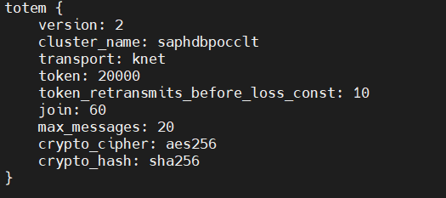

- From the host that contains the edited corosync.conf file, sync the corosync configuration across the cluster:
# pcs cluster sync corosync
- Set the cluster to start automatically:
# pcs cluster enable --all
# pcs cluster start --all
- Confirm that the new corosync settings are active in the cluster by using the corosync-cmapctl utility:
# corosync-cmapctl
Set up fencing
- Manually verify that the fence agent is able to communicate with the fence device
[root@u0bvhdbpoc002 ~]# fence_vmware_soap -a w0bvc001 -l 'myl\svc_osfence' -p <password_refer_passwordvault> --ssl-insecure -o list|grep -i u0bvhdbpoc
U0Bvhdbpoc002,422ba5a6-38f4-d5cc-4640-483e5f1f6243
U0Bvhdbpoc001,422bc1a3-32e3-6a3c-dc6f-be7682c0e086
- Manually fence the Cluster node and validate service account having privilege to fence the node

- Create STONITH Device and add it into the cluster resource by,
pcs stonith create FENCE_HAT_00 fence_vmware_soap pcmk_host_map="u0bvhdbpoc001:U0Bvhdbpoc001;u0bvhdbpoc002:U0Bvhdbpoc002" ipaddr='w0bvc001' ssl=1 login='myl\svc_osfence' passwd=<password> ssl_insecure=1
- Tuning: (Optional)
  - If stonith device having failure, replace the hostname with IP address of Vcenter
  - If stonith device having Timeout error frequently, Increase the timeout value
Set a delay for the restart of Corosync
1. On both hosts as root, create a systemd drop-in file that delays the startup of Corosync to ensure the proper sequence of events after a fenced VM is rebooted:
systemctl edit corosync.service
2. Add the following lines to the file:
[Service]
ExecStartPre=/bin/sleep 60
3. Save the file and exit the editor.
4. Reload the systemd manager configuration.
systemctl daemon-reload
5. Confirm the drop-in file was created:
service corosync status
You should see a line for the drop-in file, as shown in the following example:
● corosync.service - Corosync Cluster Engine
Loaded: loaded (/usr/lib/systemd/system/corosync.service; disabled; vendor preset: disabled)
Drop-In: /etc/systemd/system/corosync.service.d
└─override.conf
Active: active (running) since Tue 2021-07-20 23:45:52 UTC; 2 days ago
Increase the Pacemaker timeout value for reboots
1. On each host as root, increase the Pacemaker timeout value for reboots to account for the startup delay.
crm_resource --resource STONITH-"host-name --set-parameter=pcmk_reboot_timeout --parameter-value=300
The pcmk_reboot_timeout value should be greater than the sum of:
• The Corosync token timeout
• The Corosync consensus timeout
• The length of time it takes a reboot operation to complete, including any delay attribute.
2. Confirm the new pcmk_reboot_timeout value:
crm_resource --resource STONITH-host-name --get-parameter=pcmk_reboot_timeout
VIP configuration:
- Configure the VIP or Floating IP in Cluster:
  - Floating IP – It should be production or end user communication IP address
  - VLAN of the floating IP was configured at Both Node NIC
  - Better to choose same VLAN as persistent IP
  - Add the IP which needs to be high-available to the cluster,
- Configure the VIP or Floting IP in Cluster:
  - Floating IP – It should be production or end user communication IP address
  - VLAN of the floating IP was configured at Both Node NIC
  - Better to choose same VLAN as persistent IP
# pcs resource create vip_HAT_00 ocf:heartbeat:IPaddr2 ip=172.20.34.38 cidr_netmask=22 op monitor interval=30s
Enable the SAP HANA HA/DR provider hook
The SAP HANA HA/DR provider hook allows SAP HANA to send out notifications for certain events and improves failure detection.
- As root on either host, stop the cluster:
# pcs cluster stop --all
- On both hosts:
- As hatadm, stop SAP HANA:
> HDB stop
- As root, install the provided SAP HANA script:
# mkdir -p /hana/shared/myHooks
# cp /usr/share/SAPHanaSR/srHook/SAPHanaSR.py /hana/shared/myHooks
# chown -R hatadm:sapsys /hana/shared/myHooks
- As root, open the global.ini file for editing:
# vi /hana/shared/HAT/global/hdb/custom/config/global.ini
- Add the following definitions to the global.ini file:
[ha_dr_provider_SAPHanaSR]
provider = SAPHanaSR
path = /hana/shared/myHooks
execution_order = 1
[trace]
ha_dr_saphanasr = info
- As root, create a sudo configuration file to allow the hook script to update the node attributes when the srConnectionChanged()hook is called:
# vi /etc/sudoers.d/20-saphana
- In the /etc/sudoers.d/20-saphana file, add the following text:
Cmnd_Alias SOK = /usr/sbin/crm_attribute -n hana_HAT_glob_srHook -v SOK -t crm_config -s SAPHanaSR
Cmnd_Alias SFAIL = /usr/sbin/crm_attribute -n hana_HAT_glob_srHook -v SFAIL -t crm_config -s SAPHanaSR
hatadm ALL=(ALL) NOPASSWD: SOK, SFAIL
- As hatadm, start SAP HANA:
> HDB start
- As hatadm, test the status reported by the hook script:
> cdtrace
> awk '/ha_dr_SAPHanaSR.*crm_attribute/ { printf "%s %s %s %s\n",$2,$3,$5,$16 }' nameserver_*
Set the cluster defaults
Set up migration thresholds and stickiness to determine the number of failovers to attempt before failure and to set the system to try restarting on the current host first. This only needs to be set on one node to apply to the cluster.
- As root on either host, start the cluster:
# pcs cluster start --all #start the cluster
- Set the resource defaults:
# pcs resource defaults resource-stickiness=1000
# pcs resource defaults migration-threshold=5000
The property resource-stickiness controls how likely a service is to stay running where it is. Higher values make the service more sticky. A value of 1000 means that the service is very sticky.
The property migration-threshold specifies the number of failures that must occur before a service fails over to another host. A value of 5000 is high enough to prevent failover for shorter-lived error situations.
You can check the resource defaults by entering pcs resource defaults.
- If the startup-fencing and stonith-enabled properties are not already set to true, set them to true now:
# pcs property set startup-fencing="true"
# pcs property set stonith-enabled="true"
You can check your proprerty settings with pcs property list.
Note: Do not specify no-quorum-policy = ignore. The ignore value is no longer supported.
Create the SAPHanaTopology resource
The SAPHanaTopology resource gets the status and configuration of HANA System Replication on the nodes. It also checks the SAP host agent.
- As root on either host, create the SAPHanaTopology resource:
# pcs resource create SAPHanaTopology_HAT_00 SAPHanaTopology SID=HAT InstanceNumber=00 op start timeout=600 op stop timeout=300 op monitor interval=10 timeout=600 clone clone-max=2 clone-node-max=1 interleave=true
- After the resource is created, check the configuration. Append -clone to the resource name to include the clone set information in the response:
# pcs resource config SAPHanaTopology_HAT_00-clone
You can check the cluster attributes by using the crm_mon -A1 command.
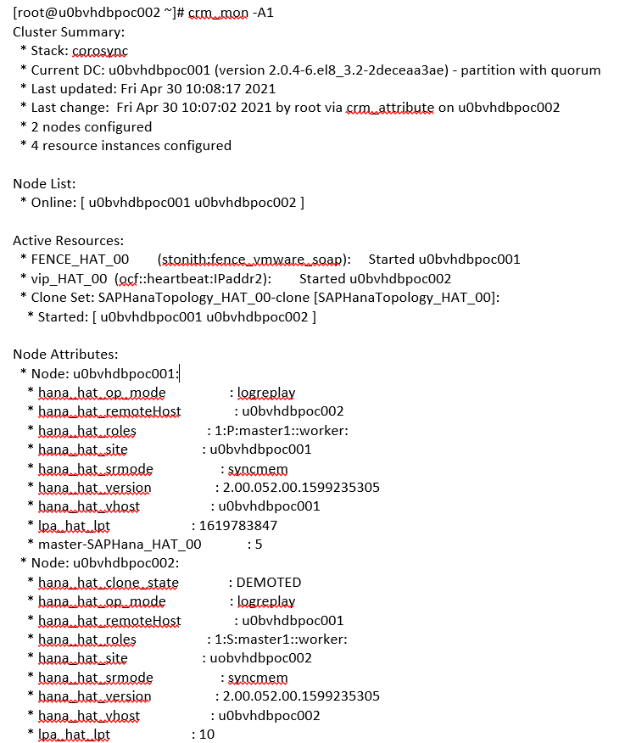
Create the SAPHana resource
The SAPHana resource agent manages the databases that are configured for SAP HANA system replication.
- As root on either host, create the SAP HANA resource:
pcs resource create SAPHana_HAT_00 SAPHana SID=HAT InstanceNumber=00 PREFER_SITE_TAKEOVER=true DUPLICATE_PRIMARY_TIMEOUT=7200 AUTOMATED_REGISTER=true op start timeout=3600 op stop timeout=3600 op monitor interval=61 role="Slave" timeout=700 op monitor interval=59 role="Master" timeout=700 op promote timeout=3600 op demote timeout=3600 promotable meta notify=true clone-max=2 clone-node-max=1 interleave=true
- After the resource is started, check the node attributes to see the current state of the SAP HANA databases on the nodes:
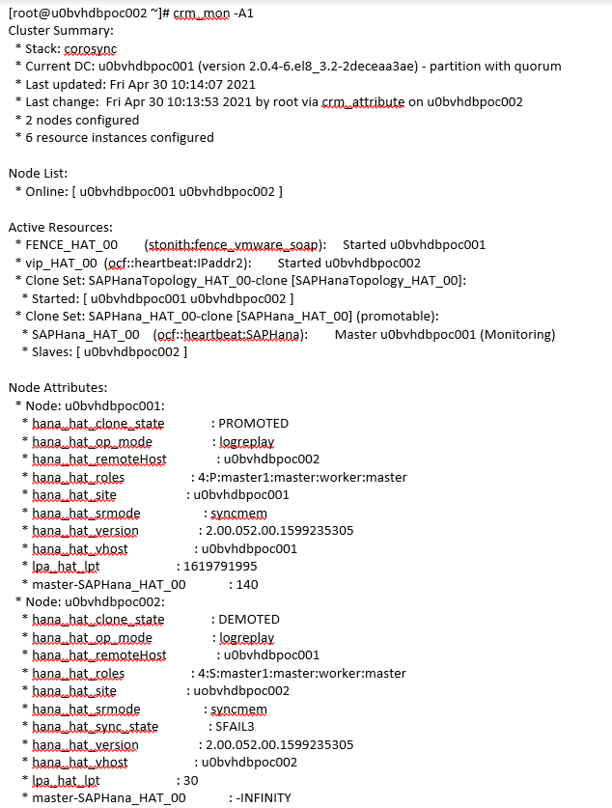
Create the constraints
You create constraints to define which services need to start first, and which services need to run together on the same host. For example, the IP address must be on the same host as the primary HANA instance.
# pcs constraint colocation add vip_HAT_00 with master SAPHana_HAT_00-clone 2000
Check the constraints:
# pcs constraint
Location Constraints:
Ordering Constraints:
start SAPHanaTopology_HAT_00-clone then start SAPHana_HAT_00-clone (kind:Mandatory) (non-symmetrical)
Colocation Constraints:
vip_HAT_00 with SAPHana_HAT_00-clone (score:2000) (rsc-role:Started) (with-rsc-role:Master)
Ticket Constraints:

pcs resource move --master SAPHana_HAT_00-clone u0bvhdbpoc001
pcs resource clear SAPHana_HAT_00-clone
Test failover
Test your cluster by simulating a failure on the primary host. Use a test system or run the test on your production system before you release the system for use.
Backup the system before the test.
You can simulate a failure in a variety of ways, including:
- HDB stop
- HDB kill
- shutdown -r (on the active node)
- ip link set eth0 down
- echo c > /proc/sysrq-trigger
Troubleshooting
You can find the logs in the following locations:
- /var/log/pacemaker/pacemaker.log
- /var/log/cluster/corosync.log
How to take Maintenance:
  - Take Backup of Cluster Configuration
  - Take Hana database backup(both system and tenant databases)
  - Keep A Node into Maintenance Mode by
# pcs node standby <node_name>
Note: resource will be migrate to another Node
  - Perform any action in that node
Can Do:
- Keep the Node to Standby to manually move the Primary role to Site-B
- Perform any Database query
- Perform any capacity extension
- Perform Hana backups
Can’t Do:
- Do not Break the replication manually, cluster will not regoganize and both the site will assume there is a failure and try to gain master role which lead hana database failure.
- Change the replication mode manually will break the cluster functionality, because cluster having configuration of replication mode
- Do not perform concurrent failover. Should be some time interval and cleanup all constraint at cluster level.

Known Issues:
- Both the Hana sites are Not promoted:
Cause: replication got broken or con-current failover will cause this issue.
Solution:
  - Stop the cluster services in both the node.
  - Take backup of both system and tenant databases
  - Re-register the primary site and secondary site
  - Shutdown the hana database at both node
  - Start cluster service
  - If the issue not resolved raise case with Both SAP and Redhat vendor.

